Joshua

The book is named after _________ understudy, Joshua. Upon Moses learning that he would die and not lead the nation into the promised land, he prayed for his replacement and the Lord appointed Joshua to be that man. Joshua means “Jehovah saves” or “the Lord is salvation.”

Author – Joshua

Date – 1405 – 1385 B.C.

Joshua was born during the time that the nation was under _________ slavery. The following are some of the highlights of his life which prepared him to lead the nation:

His __________ – Ex 17:10
His Soldering – Ex 17:9
His Scouting – Num 13-14
His __________ - Num 27
His Possession of the Spirit – Num 27

Joshua became the leader of the nation at the age of _____ and would die at ______ (Joshua 24:29) He led them for 20 years and accomplished much for the Lord. It was a faith and love for ________ that separated Joshua from his peers.

The Book Breaks Down Into 3 Sections:

__________ The Land (Ch 1-5)
__________ The Land (Ch 6-11)
__________ The Land (Ch 12-24)

Claiming The Land (Ch 1-5)

Ch 1 – God ____________ Joshua & Joshua Assumes Command

Ch 2 – Spies sent to ___________ – Rahab Emerges

Ch 3-4 – Israel Crosses _________ / Builds a _____________

Ch 5 – New Generation ___________ First Passover In Canaan/ Joshua Meeting With Jesus

Conquering The Land (Ch 6-11)

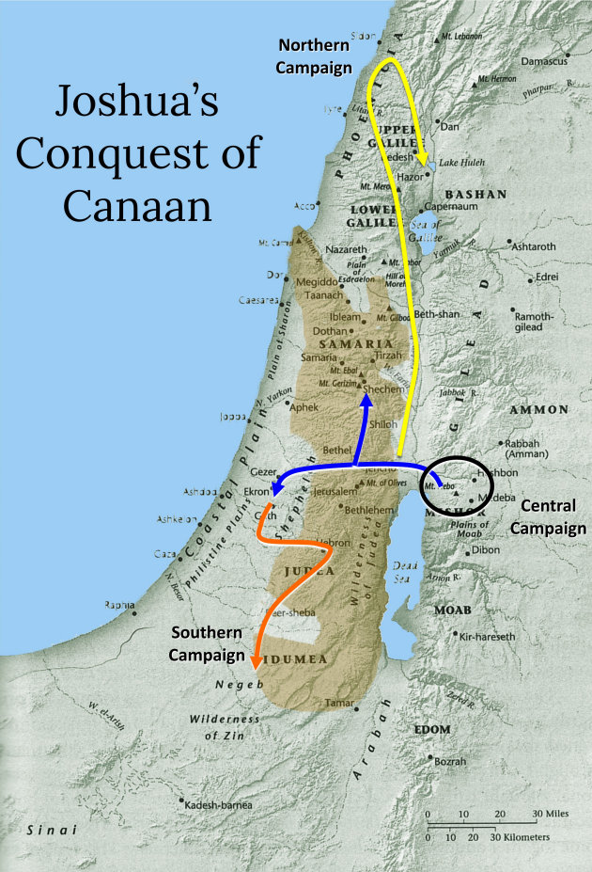

Ch 6 – The Fall of _______________

Ch 7 – Israel __________ at Ai / The Sin of ____________

Ch 8 – The Fall of Ai / Joshua Renews The Covenant

Ch 9 – The Gibeonite _____________

Ch 10 – The _______ Stands Still / 5 Amorite Kings Executed / Conquest of Southern Canaan

Ch 11 – Conquest of Northern Canaan

Colonize The Land (Ch 12-24)

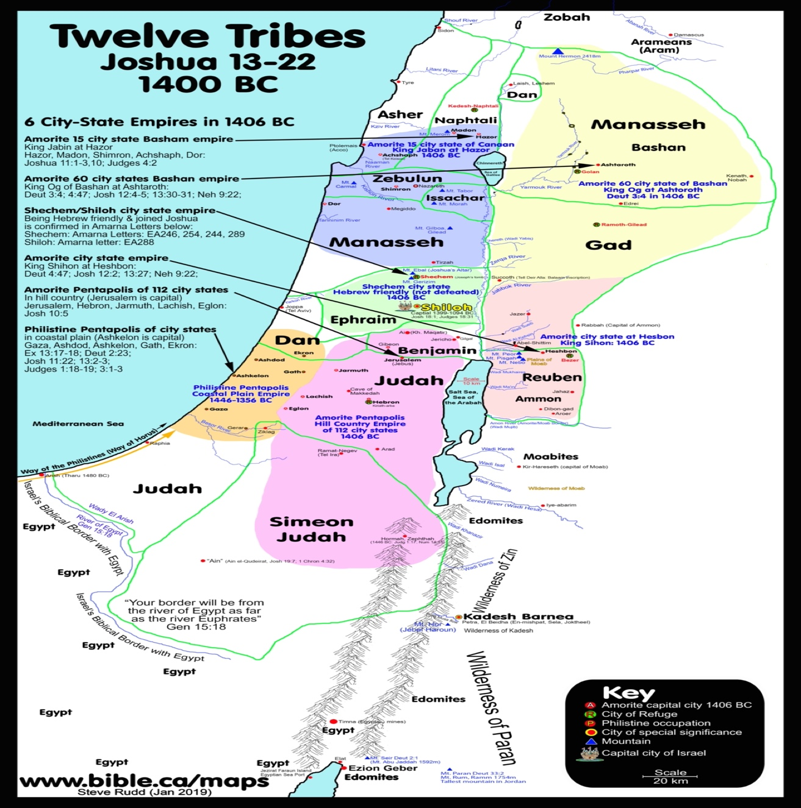

Ch 12 – _____________ Defeated By Moses & Joshua

Ch 13-14 – Lands __________ To Be Conquered / The Inheritance East & West of the Jordan / Caleb’s Inheritance

Ch 15-19 – The Allotment For The Tribes

Ch 20 – The Cities of Refuge

Ch 21 – The Cities of the Levites

Ch 22 – The Eastern Tribes Return Homes & Erect an ______ of Witness

Ch 23 – Joshua Charges to Israel’s ______________

Ch 24 – Joshua’s _________ Challenge & Death

